Concentric Polygons

Definition
# Source: AI Source: Provided by: [Data Path: Persons Table -> ID Column: 1, Name_En Column: Motasem Essam] -> From: [ChatGPT] on [7/25/2026]
Concentric Polygons are two or more polygons arranged around a common center, with each polygon having the same central point of reference but a different size.
Unlike concentric circles, where concentricity is mathematically defined by having exactly the same center, “concentric polygons” is mainly a geometric/descriptive term. The polygons are typically similar, similarly oriented, and nested around a common center.
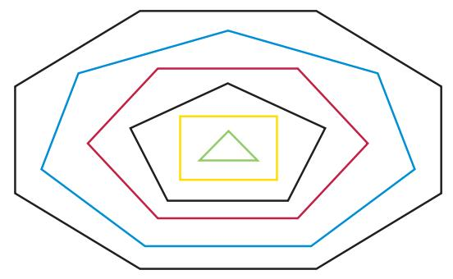
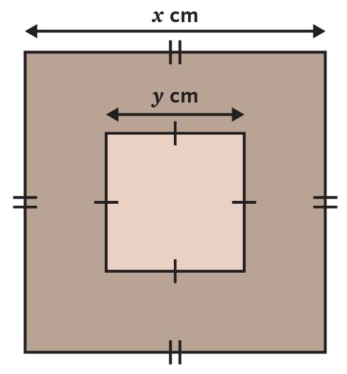
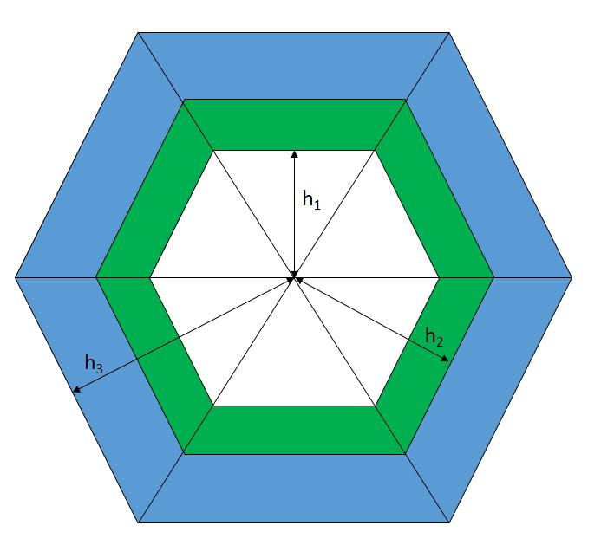
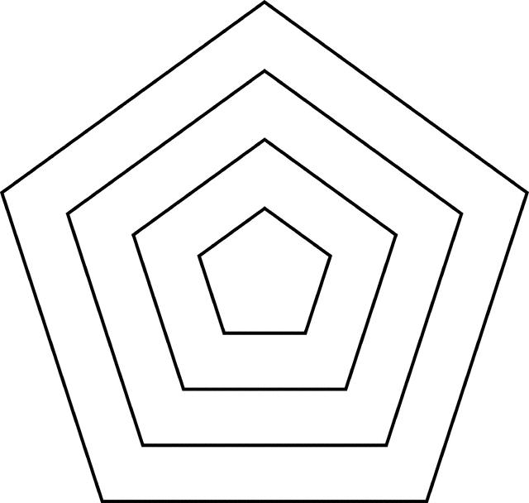
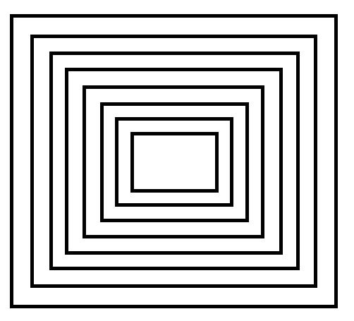
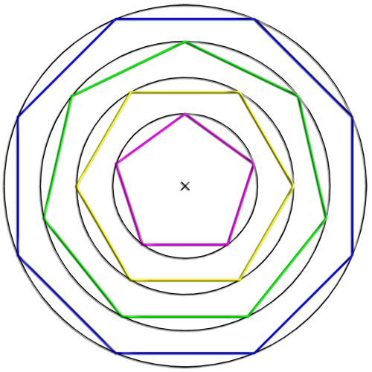

Fundamental Concept
# Source: AI Source: Provided by: [Data Path: Persons Table -> ID Column: 1, Name_En Column: Motasem Essam] -> From: [ChatGPT] on [7/25/2026]
The fundamental idea is:
Same center + nested polygons + different sizes
For two concentric polygons with common center $O$:
$$O_{1}=O_{2}=O$$
but their corresponding distances from $O$are different.
For regularly scaled polygons, one polygon can be obtained from another by a dilation centered at $O$.
If the scale factor is $k$:
$$P_{2}=D_{O,k}\left(P_{1}\right)$$
where $D_{O,k}$represents a dilation centered at $O$.

Main Characteristics
# Source: AI Source: Provided by: [Data Path: Persons Table -> ID Column: 1, Name_En Column: Motasem Essam] -> From: [ChatGPT] on [7/25/2026]
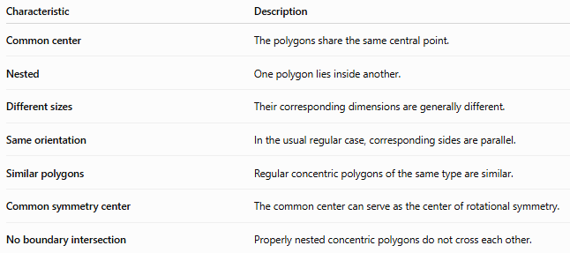
Characteristic | Description
Common center | The polygons share the same central point.
Nested | One polygon lies inside another.
Different sizes | Their corresponding dimensions are generally different.
Same orientation | In the usual regular case, corresponding sides are parallel.
Similar polygons | Regular concentric polygons of the same type are similar.
Common symmetry center | The common center can serve as the center of rotational symmetry.
No boundary intersection | Properly nested concentric polygons do not cross each other.

Basic Structure
# Source: AI Source: Provided by: [Data Path: Persons Table -> ID Column: 1, Name_En Column: Motasem Essam] -> From: [ChatGPT] on [7/25/2026]
Consider two concentric regular polygons:
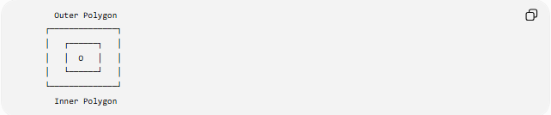
Outer Polygon
┌──────────────┐
│ ┌──────┐ │
│ │ O │ │
│ └──────┘ │
└──────────────┘
Inner Polygon
The point $O$is the common center.
For regular polygons, the distance from $O$to corresponding vertices or sides determines the size of each polygon.
For example, if the polygons are concentric squares:
$$O_{1}=O_{2}$$
while
$$s_{1}≠s_{2}$$
where $s_{1}$and $s_{2}$are their side lengths.

Types of Concentric Polygons
# Source: AI Source: Provided by: [Data Path: Persons Table -> ID Column: 1, Name_En Column: Motasem Essam] -> From: [ChatGPT] on [7/25/2026]
Concentric polygons can be classified according to the number of polygons and the polygon type.
Main classification
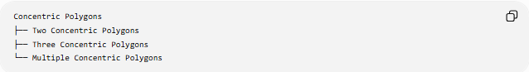
Concentric Polygons
├── Two Concentric Polygons
├── Three Concentric Polygons
└── Multiple Concentric Polygons
They can also be classified by polygon family:
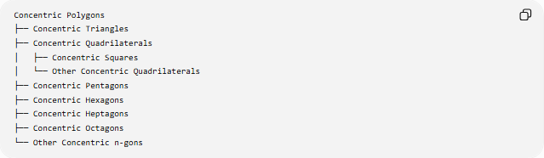
Concentric Polygons
├── Concentric Triangles
├── Concentric Quadrilaterals
│ ├── Concentric Squares
│ └── Other Concentric Quadrilaterals
├── Concentric Pentagons
├── Concentric Hexagons
├── Concentric Heptagons
├── Concentric Octagons
└── Other Concentric n-gons
The term concentric describes the shared center; it does not itself require a particular number of sides.

Two Concentric Polygons
# Source: AI Source: Provided by: [Data Path: Persons Table -> ID Column: 1, Name_En Column: Motasem Essam] -> From: [ChatGPT] on [7/25/2026]
Two polygons are concentric when they are positioned around the same center.
For example, two concentric squares:
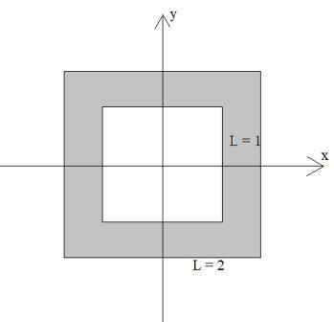
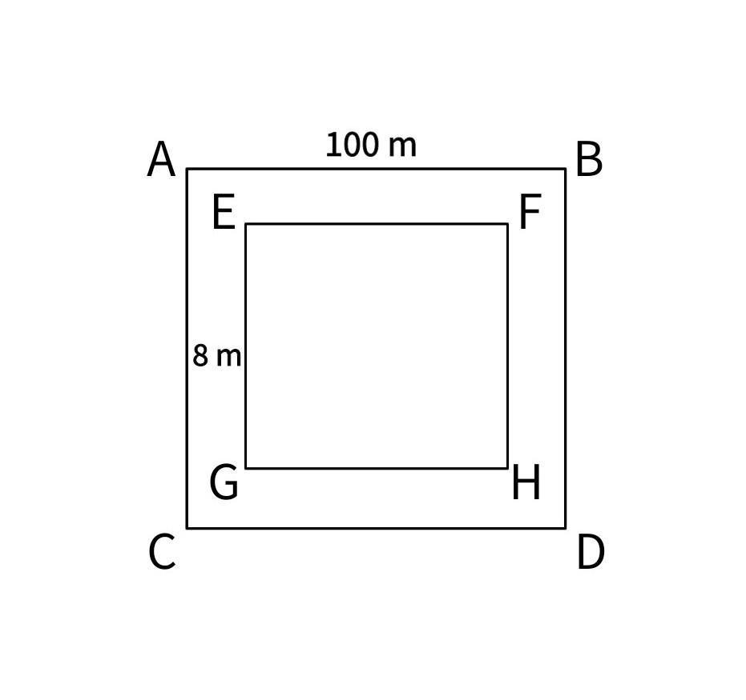
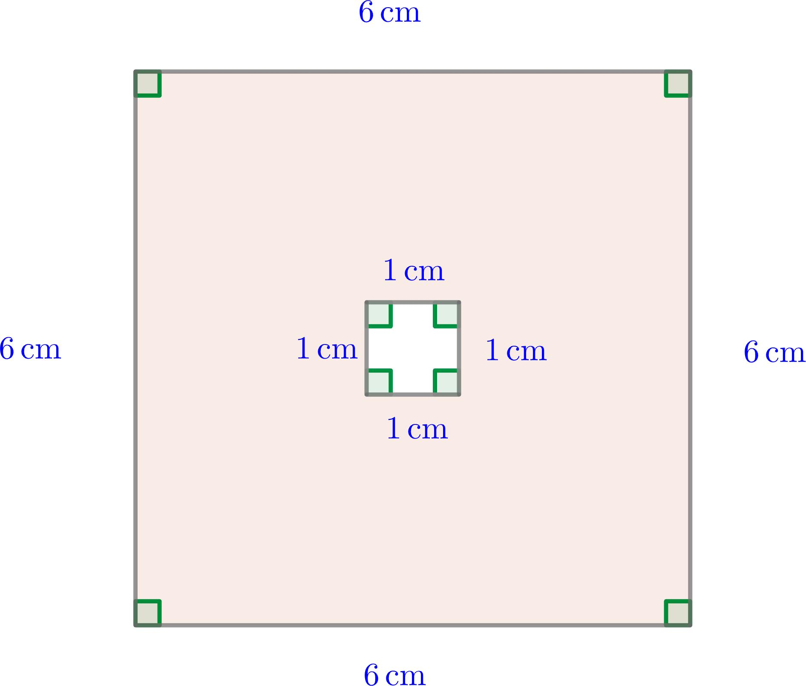
If their side lengths are $s_{1}$and $s_{2}$:
$$s_{1}<s_{2}$$
and they share center $O$.
The region between their boundaries forms a polygonal ring or frame-like region.

Three Concentric Polygons
# Source: AI Source: Provided by: [Data Path: Persons Table -> ID Column: 1, Name_En Column: Motasem Essam] -> From: [ChatGPT] on [7/25/2026]
Three polygons can share the same center:
$$O_{1}=O_{2}=O_{3}=O$$
For example:
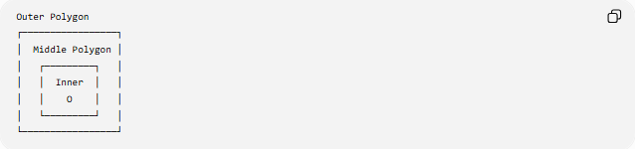
Outer Polygon
┌─────────────────┐
│ Middle Polygon │
│ ┌─────────┐ │
│ │ Inner │ │
│ │ O │ │
│ └─────────┘ │
└─────────────────┘
There are two regions between adjacent polygons:
$$P_{1}→P_{2}$$
and
$$P_{2}→P_{3}$$

Multiple Concentric Polygons
# Source: AI Source: Provided by: [Data Path: Persons Table -> ID Column: 1, Name_En Column: Motasem Essam] -> From: [ChatGPT] on [7/25/2026]
Any number of polygons can be arranged around the same center.
For $n$nested concentric polygons:
$$O_{1}=O_{2}=⋯=O_{n}=O$$
If they are ordered from smallest to largest:
$$P_{1}⊂P_{2}⊂⋯⊂P_{n}$$
There are:
$$n-1$$
regions between adjacent polygon boundaries.
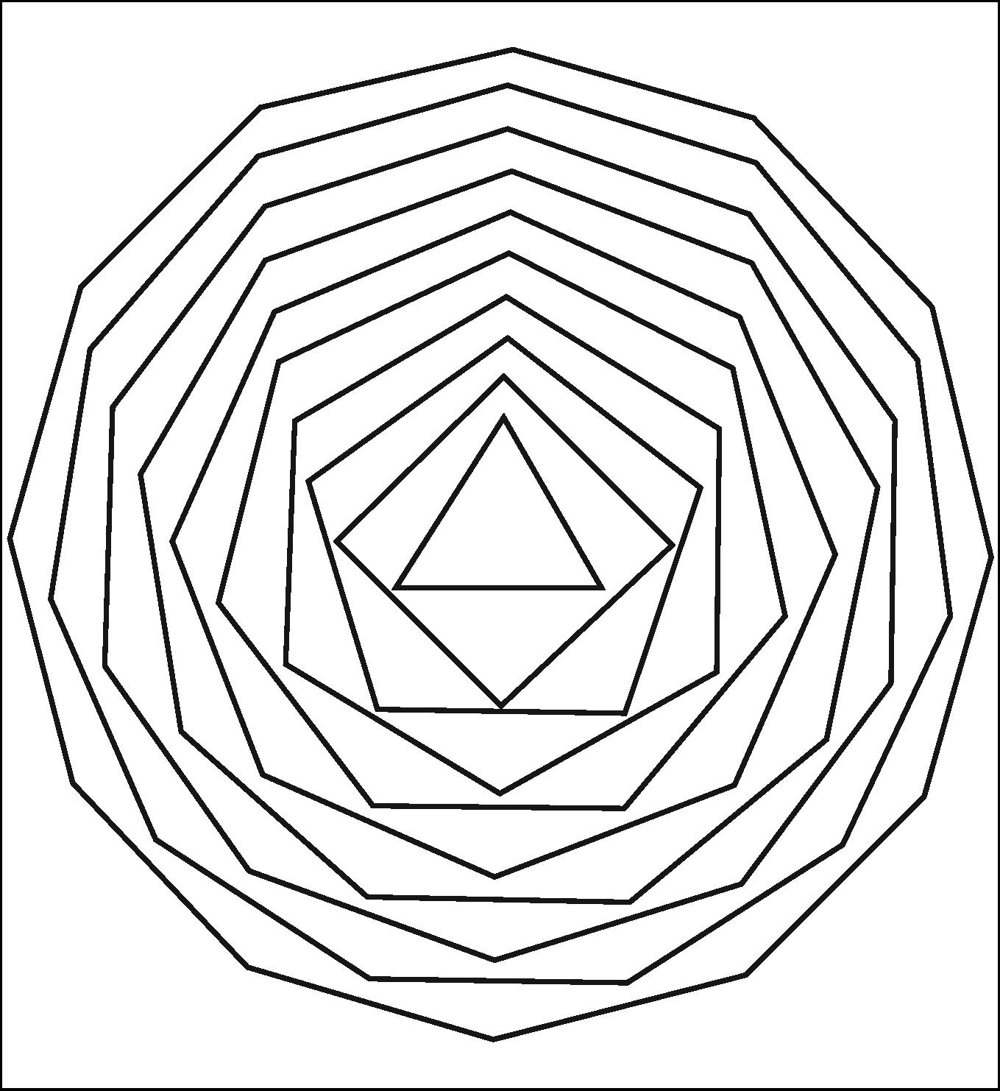
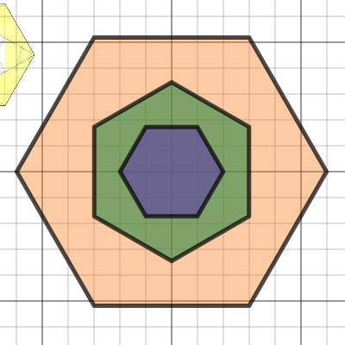
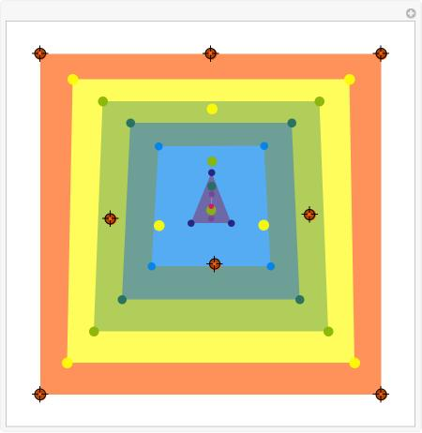

Concentric Regular Polygons
# Source: AI Source: Provided by: [Data Path: Persons Table -> ID Column: 1, Name_En Column: Motasem Essam] -> From: [ChatGPT] on [7/25/2026]
The most precise and visually common form is a set of concentric regular polygons.
For example, several regular hexagons can share the same center.
If the polygons have the same number of sides and orientation, their corresponding sides are parallel.
For regular $n$-gons, if their circumradii are $R_{1}$and $R_{2}$:
$$R_{1}<R_{2}$$
and their side lengths satisfy:
$$s=2R\sin\left(\frac{π}{n}\right)$$
Therefore:
$$\frac{s_{1}}{s_{2}}=\frac{R_{1}}{R_{2}}$$

Mathematical Properties

Common Center
# Source: AI Source: Provided by: [Data Path: Persons Table -> ID Column: 1, Name_En Column: Motasem Essam] -> From: [ChatGPT] on [7/25/2026]
For concentric polygons:
$$O_{1}=O_{2}=⋯=O_{n}$$
The same point acts as the center.

Similarity
# Source: AI Source: Provided by: [Data Path: Persons Table -> ID Column: 1, Name_En Column: Motasem Essam] -> From: [ChatGPT] on [7/25/2026]
If two regular $n$-gons are concentric and similarly oriented, they are similar:
$$P_{1}∼P_{2}$$
Their corresponding lengths have a constant ratio:
$$\frac{s_{1}}{s_{2}}=\frac{R_{1}}{R_{2}}$$

Perimeter
# Source: AI Source: Provided by: [Data Path: Persons Table -> ID Column: 1, Name_En Column: Motasem Essam] -> From: [ChatGPT] on [7/25/2026]
For a regular $n$-gon with side length $s$:
$$P=ns$$

Area
# Source: AI Source: Provided by: [Data Path: Persons Table -> ID Column: 1, Name_En Column: Motasem Essam] -> From: [ChatGPT] on [7/25/2026]
For a regular $n$-gon with side length $s$:
$$A=\frac{1}{4}ns^{2}\cot\left(\frac{π}{n}\right)$$
Using the apothem $a$:
$$A=\frac{1}{2}Pa$$

Circumradius
# Source: AI Source: Provided by: [Data Path: Persons Table -> ID Column: 1, Name_En Column: Motasem Essam] -> From: [ChatGPT] on [7/25/2026]
For a regular $n$-gon:
$$R=\frac{s}{2sin⁡\left(π/n\right)}$$

Apothem
# Source: AI Source: Provided by: [Data Path: Persons Table -> ID Column: 1, Name_En Column: Motasem Essam] -> From: [ChatGPT] on [7/25/2026]
For a regular $n$-gon:
$$a=\frac{s}{2tan⁡\left(π/n\right)}$$
The center of the polygon is the point from which the apothem is measured.

Polygonal Ring Between Concentric Polygons
# Source: AI Source: Provided by: [Data Path: Persons Table -> ID Column: 1, Name_En Column: Motasem Essam] -> From: [ChatGPT] on [7/25/2026]
When a smaller polygon lies inside a larger concentric polygon, the region between them can be considered a polygonal ring or polygonal annular region.
For two regular concentric $n$-gons, the area between them is:
$$A_{\text{ring}}=A_{\text{outer}}-A_{\text{inner}}$$
Therefore:
$$\boxed{A_{\text{ring}}=\frac{1}{4}n\left(s_{2}^{2}-s_{1}^{2}\right)\cot\left(\frac{π}{n}\right)}$$
where:
- $s_{2}$= side length of the outer polygon
- $s_{1}$= side length of the inner polygon

Concentric Squares
# Source: AI Source: Provided by: [Data Path: Persons Table -> ID Column: 1, Name_En Column: Motasem Essam] -> From: [ChatGPT] on [7/25/2026]
Concentric squares are one of the simplest examples.
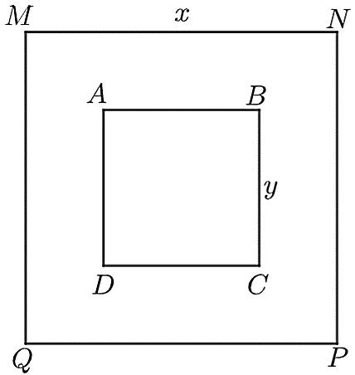
For squares:
$$n=4$$
and the area is:
$$A=s^{2}$$
For two concentric squares:
$$A_{\text{between}}=s_{2}^{2}-s_{1}^{2}$$
If:
$$s_{1}=4$$
and
$$s_{2}=10$$
then:
$$A_{\text{between}}={10}^{2}-4^{2} \\ =100-16 \\ \boxed{84}$$
square units.

Concentric Regular Polygons and Dilation
# Source: AI Source: Provided by: [Data Path: Persons Table -> ID Column: 1, Name_En Column: Motasem Essam] -> From: [ChatGPT] on [7/25/2026]
Concentric regular polygons can be related through dilation.
Suppose the inner polygon is transformed into the outer polygon by a scale factor $k$.
Then:
$$k=\frac{s_{2}}{s_{1}}$$
All corresponding lengths are multiplied by $k$.
Areas are multiplied by:
$$k^{2}$$
Therefore:
$$\frac{A_{2}}{A_{1}}=k^{2}$$
This is an important mathematical relationship between similarly oriented concentric regular polygons.

Concentric Polygons vs. Concentric Circles
# Source: AI Source: Provided by: [Data Path: Persons Table -> ID Column: 1, Name_En Column: Motasem Essam] -> From: [ChatGPT] on [7/25/2026]
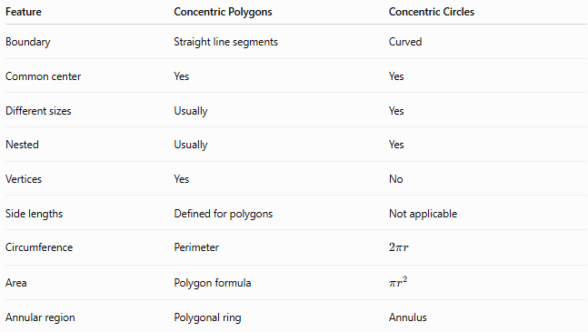
Feature | Concentric Polygons | Concentric Circles
Boundary | Straight line segments | Curved
Common center | Yes | Yes
Different sizes | Usually | Yes
Nested | Usually | Yes
Vertices | Yes | No
Side lengths | Defined for polygons | Not applicable
Circumference | Perimeter | $$2πr$$
Area | Polygon formula | $$πr^{2}$$
Annular region | Polygonal ring | Annulus
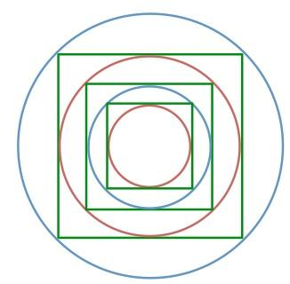
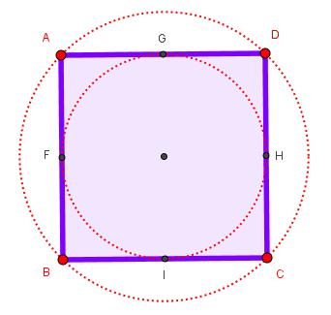
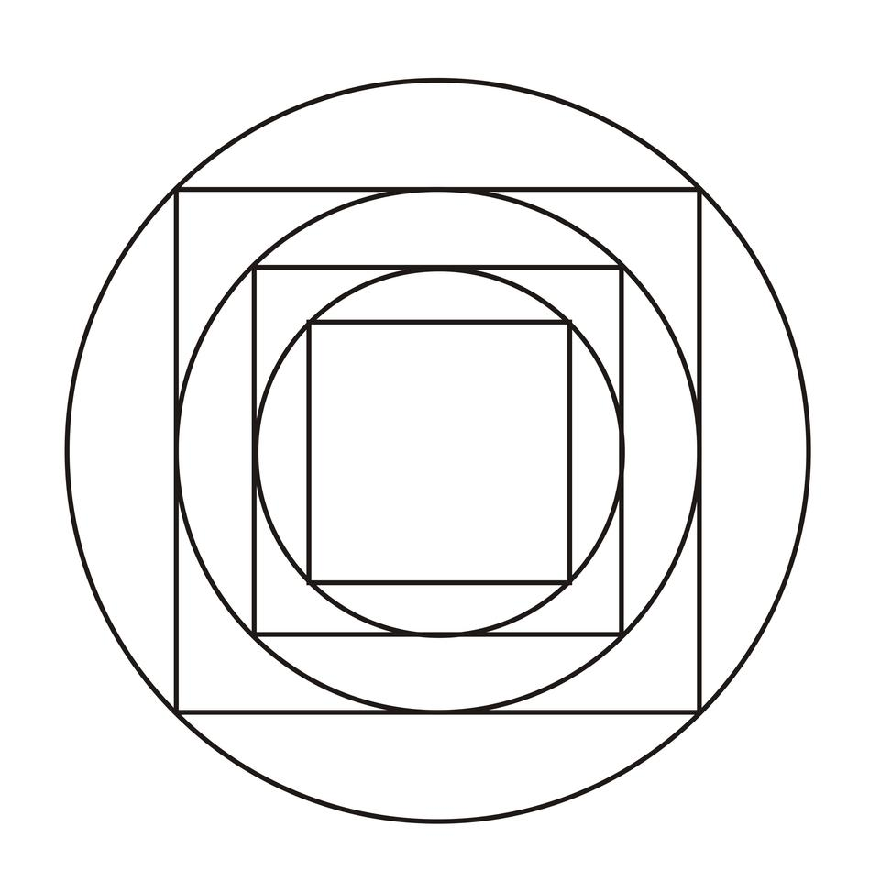

Concentric Polygons vs. Similar Polygons
# Source: AI Source: Provided by: [Data Path: Persons Table -> ID Column: 1, Name_En Column: Motasem Essam] -> From: [ChatGPT] on [7/25/2026]
These concepts are related but not identical.
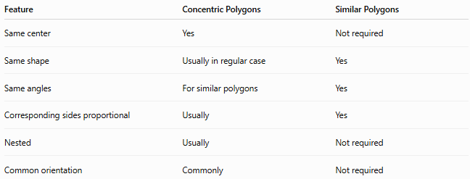
Feature | Concentric Polygons | Similar Polygons
Same center | Yes | Not required
Same shape | Usually in regular case | Yes
Same angles | For similar polygons | Yes
Corresponding sides proportional | Usually | Yes
Nested | Usually | Not required
Common orientation | Commonly | Not required
For example, two similar triangles can be located far apart and therefore are not concentric.

Examples

Example 1 — Two concentric squares
# Source: AI Source: Provided by: [Data Path: Persons Table -> ID Column: 1, Name_En Column: Motasem Essam] -> From: [ChatGPT] on [7/25/2026]
Two squares have the same center:
$$O_{1}=O_{2}$$
with side lengths:
$$s_{1}=6, s_{2}=12$$
The area between them is:
$$A={12}^{2}-6^{2} \\ A=144-36 \\ \boxed{A=108}$$
square units.

Example 2 — Concentric regular hexagons
# Source: AI Source: Provided by: [Data Path: Persons Table -> ID Column: 1, Name_En Column: Motasem Essam] -> From: [ChatGPT] on [7/25/2026]
For two regular hexagons with side lengths $4$and $8$:
$$A=\frac{3\sqrt{3}}{2}s^{2}$$
Therefore:
$$A_{1}=\frac{3\sqrt{3}}{2}\left(4^{2}\right)$$
and
$$A_{2}=\frac{3\sqrt{3}}{2}\left(8^{2}\right)$$
The larger hexagon has four times the area because its linear dimensions are doubled.

Classification Summary
# Source: AI Source: Provided by: [Data Path: Persons Table -> ID Column: 1, Name_En Column: Motasem Essam] -> From: [ChatGPT] on [7/25/2026]
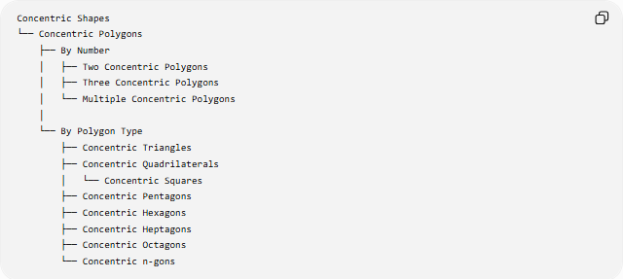
Concentric Shapes
└── Concentric Polygons
├── By Number
│ ├── Two Concentric Polygons
│ ├── Three Concentric Polygons
│ └── Multiple Concentric Polygons
│
└── By Polygon Type
├── Concentric Triangles
├── Concentric Quadrilaterals
│ └── Concentric Squares
├── Concentric Pentagons
├── Concentric Hexagons
├── Concentric Heptagons
├── Concentric Octagons
└── Concentric n-gons
For the particularly important regular case:
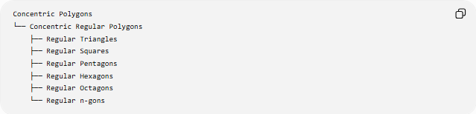
Concentric Polygons
└── Concentric Regular Polygons
├── Regular Triangles
├── Regular Squares
├── Regular Pentagons
├── Regular Hexagons
├── Regular Octagons
└── Regular n-gons

Key Points
# Source: AI Source: Provided by: [Data Path: Persons Table -> ID Column: 1, Name_En Column: Motasem Essam] -> From: [ChatGPT] on [7/25/2026]
- Concentric polygons share a common center.
- They are generally arranged as nested polygons of different sizes.
- The term is primarily descriptive, unlike the precise standard definition of concentric circles.
- Concentric regular polygons of the same type are similar.
- A dilation centered at the common center can relate similarly oriented concentric polygons.
- Corresponding linear dimensions scale by $k$.
- Corresponding areas scale by $k^{2}$.
- For $n$nested concentric polygons, there are $n-1$regions between adjacent boundaries.
- The region between two concentric polygons can be treated as a polygonal ring.
- Concentricity describes the shared center, not the number of sides or regularity of the polygons.

Conclusion
# Source: AI Source: Provided by: [Data Path: Persons Table -> ID Column: 1, Name_En Column: Motasem Essam] -> From: [ChatGPT] on [7/25/2026]
Concentric Polygons are nested polygons organized around a common center. The concept is especially useful for regular polygons, where the polygons can be related by dilation and their corresponding lengths, perimeters, and areas follow predictable scale relationships. Unlike concentric circles, the term is mainly a geometric description rather than a universally standardized polygon classification.

